PIZZA SALES SQL QUERIES

* KPI’s

1. Total Revenue:

select sum(total_price) as total_revenue from pizza_sale



1. Average order value

select sum(total_price) / count(distinct order_id) as avg_order_value from pizza_sales



3.Pizza sold by pizza category

select sum(quantity) as pizza_sold from pizza_sales



1. Average pizza per order

select cast(cast(sum(quantity) as decimal(10,2)) / cast(count(distinct order_id) as decimal(10,2))as decimal(10,2)) as avg_pizza_per_order from pizza_sales



* Chart query

1. Daily trend for total orders

SELECT DATENAME(DW,order_date) as order_day, count(distinct order_id) as total_orders from pizza_sales

group by DATENAME(DW,order_date)

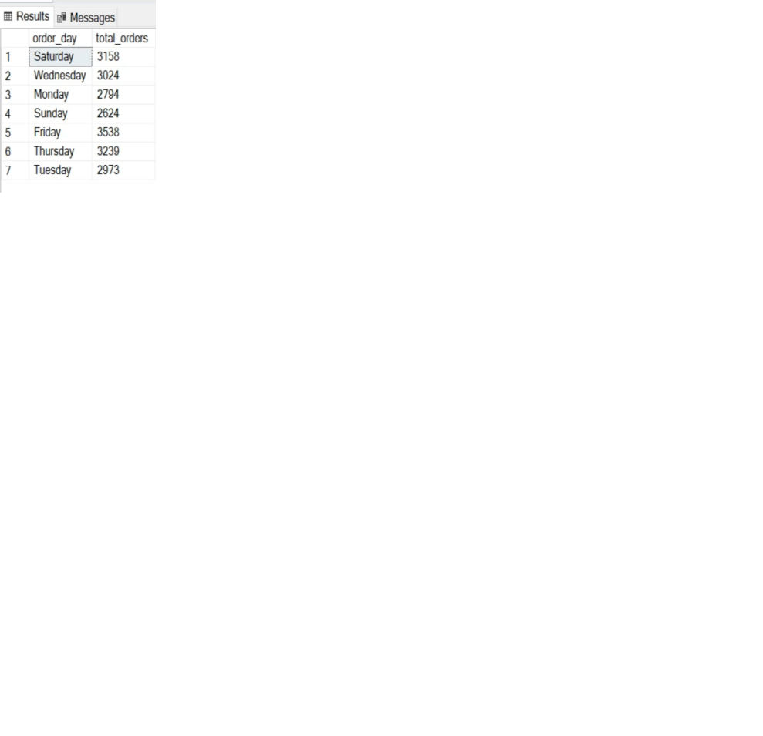

1. Monthly trends for total orders

SELECT DATENAME(MONTH,order_date) as month_name, count(distinct order_id) as total_orders from pizza_sales

group by DATENAME(MONTH,order_date)

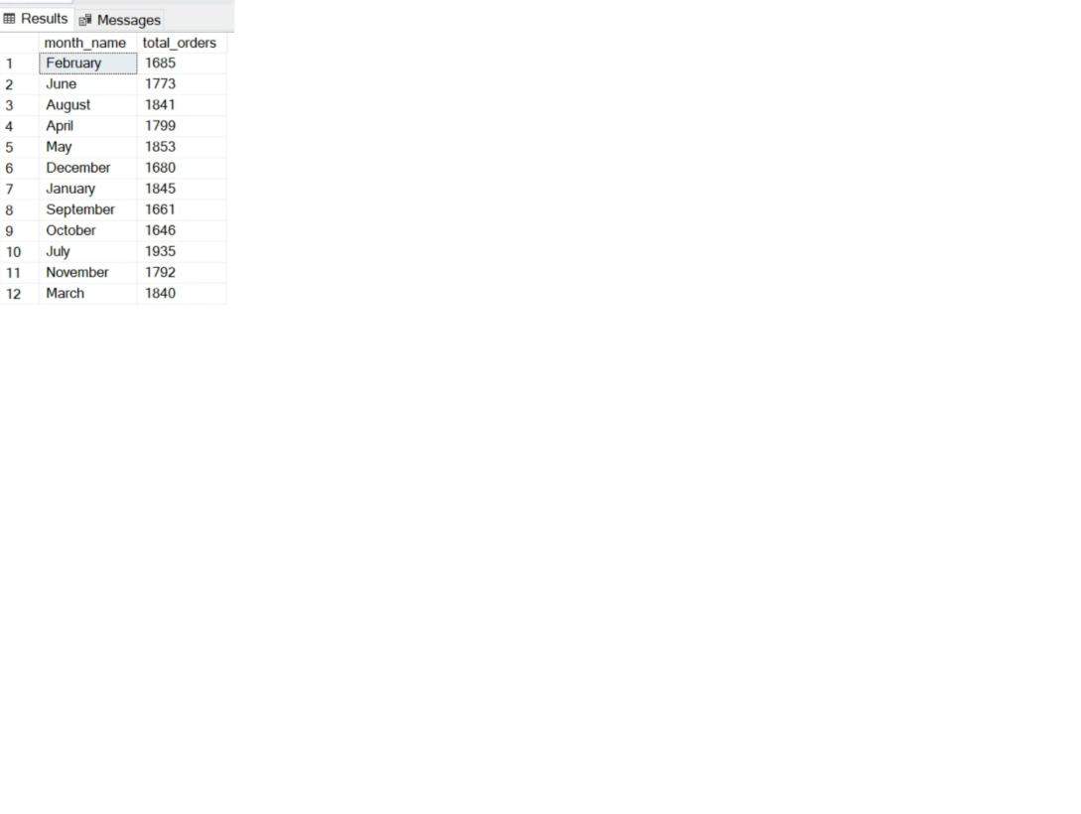

3.Monthly trends in descending order

SELECT DATENAME(MONTH,order_date) as month_name, count(distinct order_id) as total_orders from pizza_sales

group by DATENAME(MONTH,order_date)

order by total_orders desc

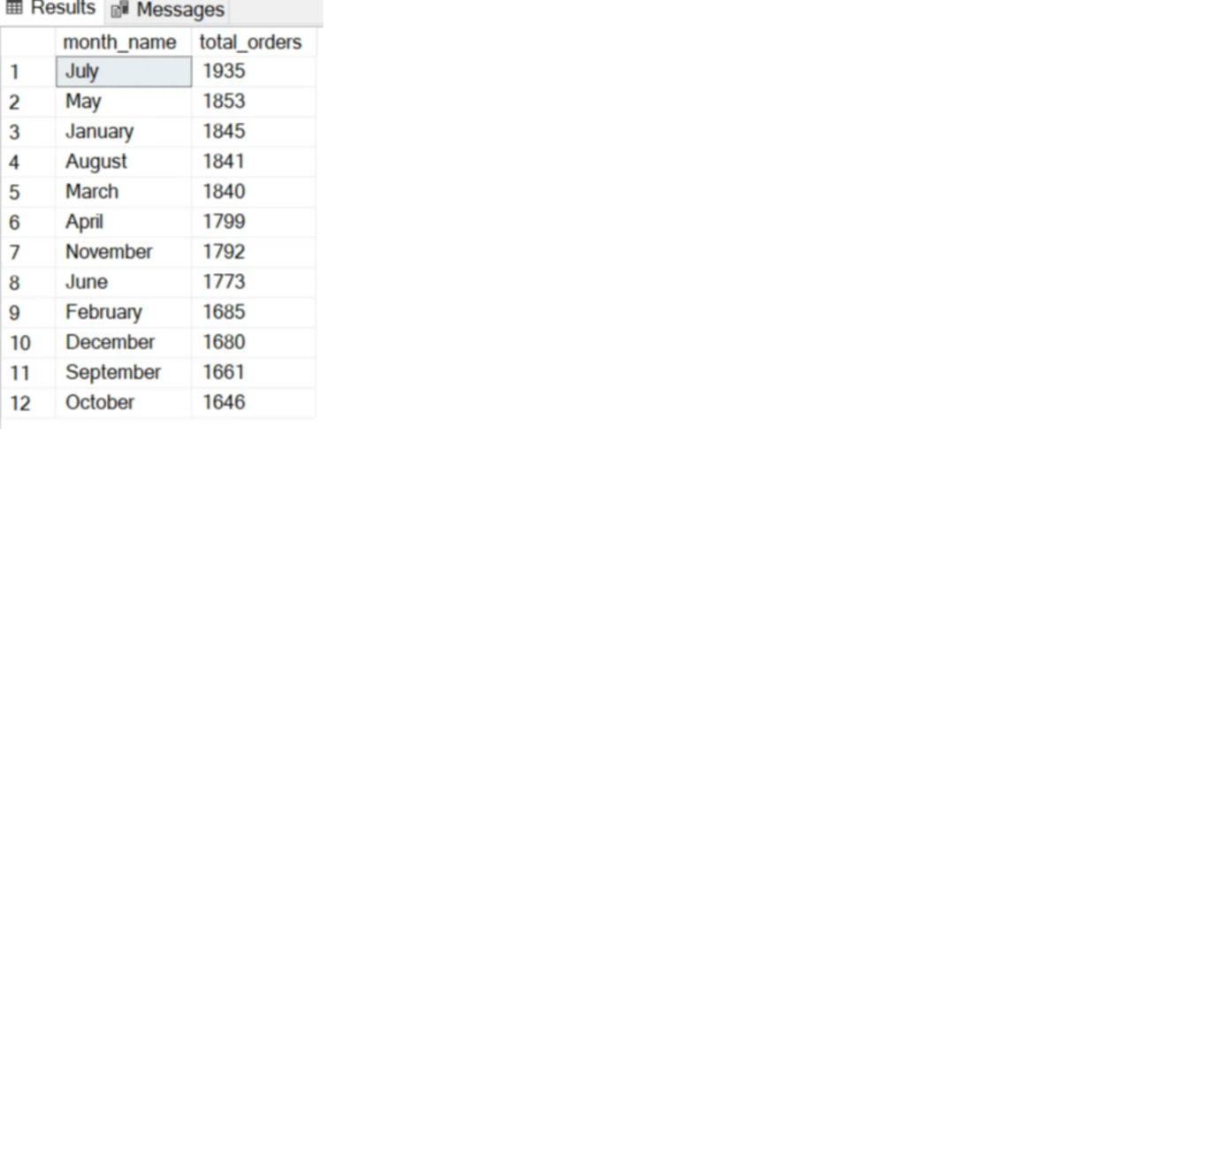

4.Percentage of sales by pizza category

select pizza_category, sum(total_price) as total_sales_per_category, sum(total_price)* 100/ (select sum(total_price) from pizza_sales where MONTH(order_date) = 1)as total_sales from pizza_sales

where MONTH(order_date) = 1

group by pizza_category

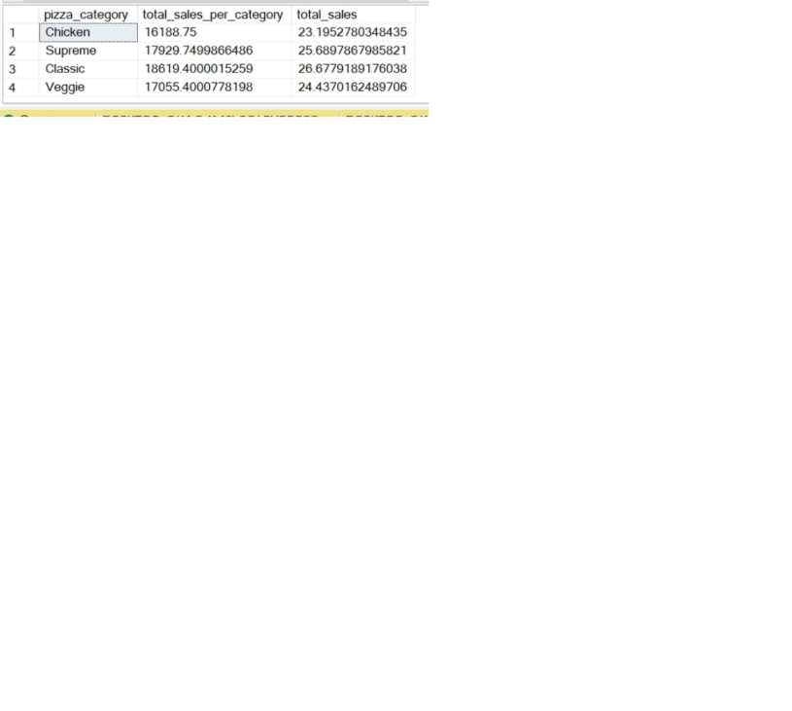

5.Percentage of sales by pizza size

select * from pizza_sales

select pizza_size, sum(total_price) as total_sales_per_category, sum(total_price)* 100/ (select sum(total_price) from pizza_sales where DATEPART(quarter,order_date)=1 )as PCT from pizza_sales

where DATEPART(quarter,order_date)=1

group by pizza_size

order by PCT DESC

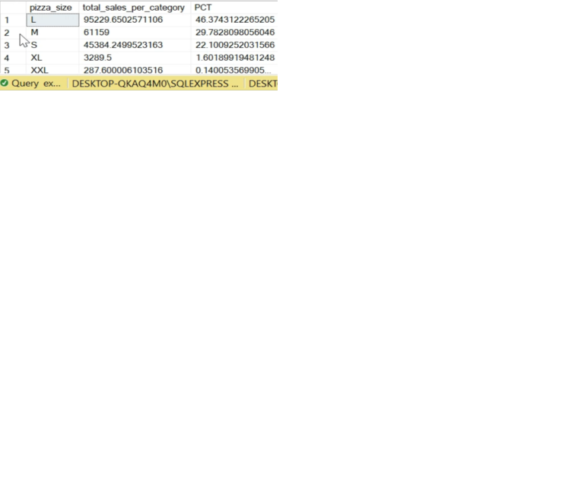

6.Top 5 pizzas using pizza sales

select * from pizza_sales

select top 5 pizza_name,sum(total_price) as total_sales from pizza_sales

group by pizza_name

order by total_sales desc

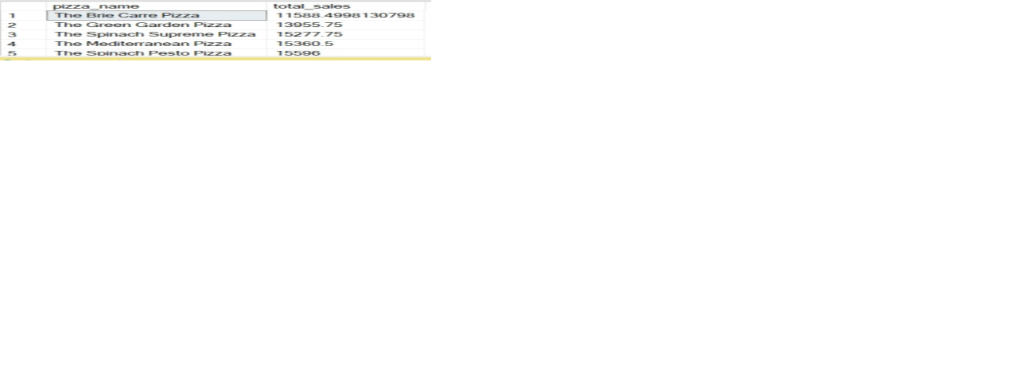

7.Bottom 5 pizzas using pizza sales

select * from pizza_sales

select top 5 pizza_name,sum(total_price) as total_sales from pizza_sales

group by pizza_name

order by total_sales

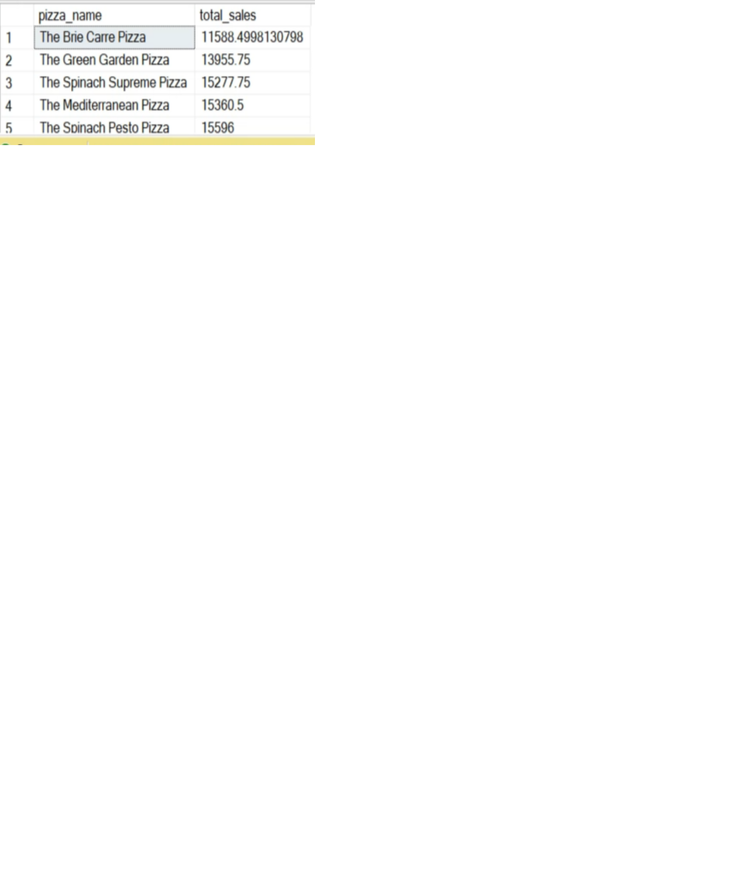

8.Top 5 pizzas using pizza quantity

select * from pizza_sales

select top 5 pizza_name,sum(quantity) as total_quantity from pizza_sales

group by pizza_name

order by total_quantity desc

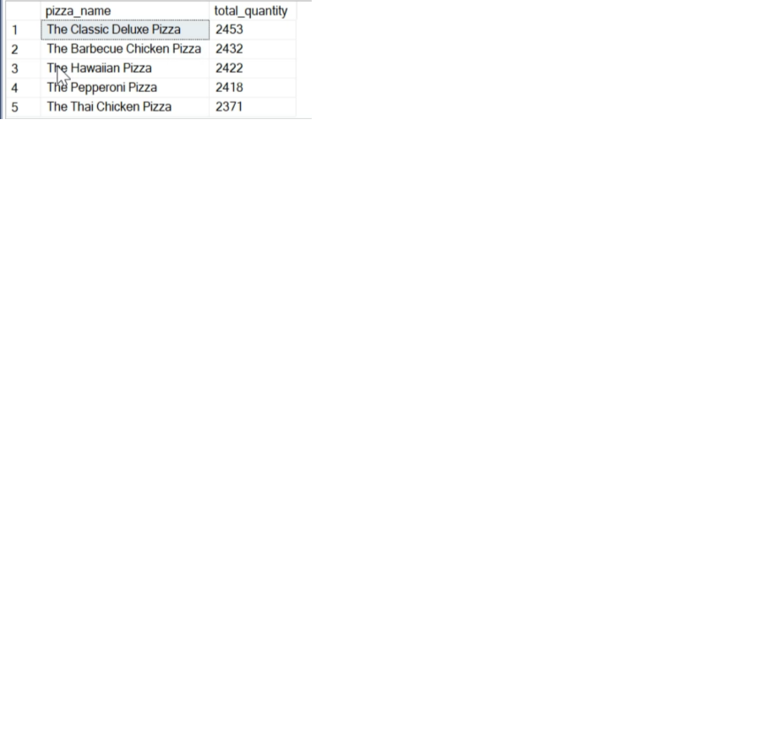

9.Bottom 5 pizzas using pizza quantity

select * from pizza_sales

select top 5 pizza_name,sum(quantity) as total_quantity from pizza_sales

group by pizza_name

order by total_quantity

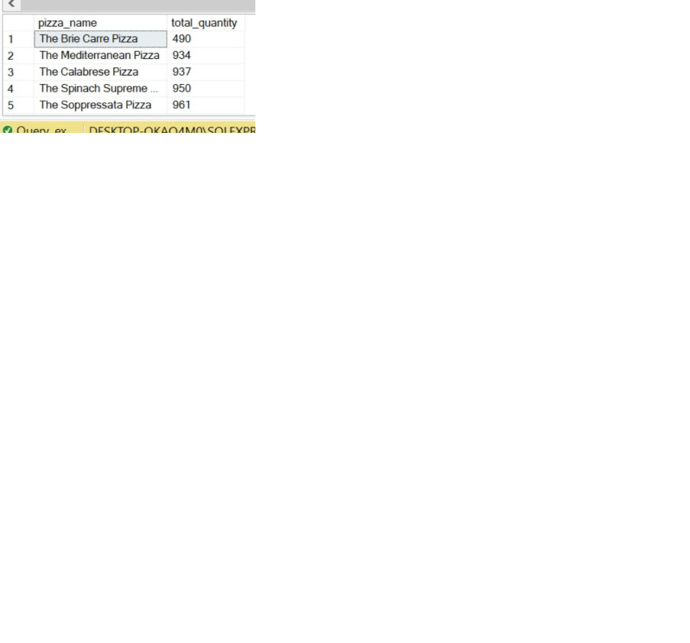

10.Top 5 pizzas using pizza orders

select * from pizza_sales

select top 5 pizza_name,count(distinct order_id) as total_orders from pizza_sales

group by pizza_name

order by total_orders desc

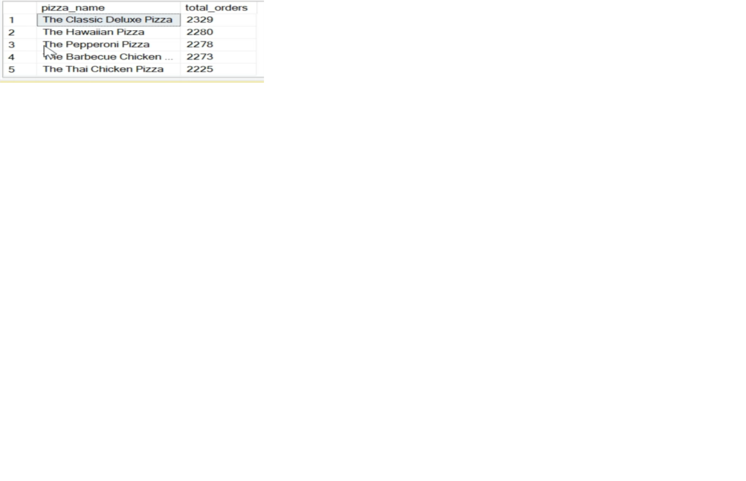

1. Bottom 5 pizzas using pizza sales

select * from pizza_sales

select top 5 pizza_name,count(distinct order_id) as total_orders from pizza_sales

group by pizza_name

order by total_orders

